Enterprise Launching Formalities | Meaning & Stages in Launching the Enterprise

What is Enterprise Launching Formalities ?

It is quite difficult for a new entrepreneur to promote a venture as it involves series of different steps. A potential entrepreneur has to follow a step-by-step approach to start a new venture. The first milestone on which the initiation of an enterprise depends is deciding and encouraging the self. Similarly, if the correct venture is selected by the entrepreneur, his half of the job is completed.

In order to abide by various land-related laws, different types of situations have to be faced by the entrepreneur for establishing and managing a new venture or small, scale enterprise. All the governmental formalities, plans and legal policies must be followed carefully from the very conception stage of the enterprise growth so that no legal difficulties occur in future.

Stages in Enterprise Launching Formalities

The different stages from which a business enterprise has to undergo during its development phase. 10 formalities for setting up a business enterprise are stated below :

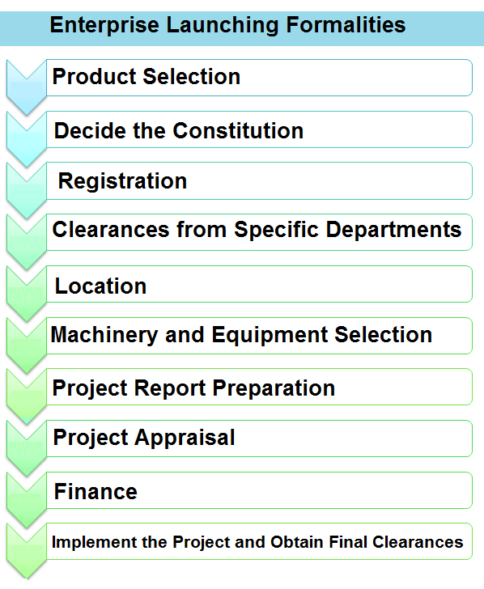

1) Product Selection :
Deciding the type of business, selecting the product or product range for manufacturing along with its quantity is the most vital step. The size and the type of business ownership will be decided on the basis of level of business activities. With the help of environment scanning and short listing, a number of project ideas can be developed by any entrepreneur. Every alternative can be evaluated closely with the help of opportunity analysis and then final products can be decided.
The most critical facet of any successful project is a strong entrepreneur. For the entrepreneur to develop a small-scale industry, a suitable project needs to be decided, which mainly involves the selection of product or service and a perfect location for the business unit. Depending upon these choices, a project feasibility study needs to be conducted followed by preparation of a brief profile for the proposed project. Accordingly, a suitable business plan should also be made.
Thus, the first decision which an entrepreneur has to make is project selection. The following things will be included in the project selection and preliminary activities :
- Selecting the product/service,
- Selecting the location,
- Conducting Project feasibility study,
- Preparing the business plan,
- Preparing a project profile.

2) Decide the Constitution :
Most of the new entrepreneurs do not have a clear vision related to various legal issues and other government-related factors associated with the selection of a certain business, which could result in mistakes costing time and money. In India, most of the entrepreneurs tend to start a private limited firm.
The constitution of the business unit has to be decided by its promoters before starting any industry, which are mainly of following types:
- Sole proprietorship.
- Partnership,
- Corporation/Limited Company,
- Cooperative,
- Franchising.
All these alternatives will be decided on the basis of the objective, size and type of the business. Depending upon the available resources or the type of investment, the form of ownership is also decided. During the initial stages, it is important to decide the constitution of the unit and before applying for the Provisional Registration Certificate, all the necessary formalities must be finished.

3) Registration :
Registration of a new venture is very important. Though not mandatory, but registration is very advantageous for a business unit as it provides a legal identification and status to the business so that it can execute all its legal rights. A registered business unit is, provided with government assistance, incentives and licenses to import raw materials. Briefly, a business can ensure all its legal rights by registering itself.

Maintaining the statistics and role of different business units for providing various promotional plans and incentives is the main objective of registration. According to the guidelines of Central Government, there a uniform registration process for the business units. However, in some states the guidelines vary with some modifications done by the State Government. Also, similar registration schemes are used by the States for the implementation of their own policy implementation. In some states, "SIDO registration scheme" or "State registration scheme" are adopted.
Objectives of the Registration Scheme :
- Detailing and maintaining the role of small industries for providing support and various incentives.
- Providing certificates to business units so that can avail their statutory benefits, usually in they can terms of protection.
- Collecting statistics.
- Developing nodal centres at the Central, State and District levels for promoting Small Scale Industries (SSI).
Features of the Registration Scheme :
- Main registering centre is District Industries Centre (DIC).
- It is not mandatory for the firm to get registered.
- There are two forms of registration done under all States. First, a Provisional Registration Certificate is provided and then a Permanent Registration Certificate is given, once the production starts.
- Validity of Provisional Registration Certificate is 5 years and permanent registration is provided in perpetuity.

Benefits of Registering :

There is no statutory basis of registration scheme. However, it is done by the units for receiving various advantages, support or incentives from Central or State government. The various advantages are as below :
- Credit prescription (priority sector lending). differential interest rates, etc.,
- Scheme of excise exemption,
- Exemption under direct tax laws,
- Statutory support such as reservation and Interest on Delayed Payments Act,
- Applying for a shed or plot in an industrial estate or a developed area,
- Applying for Corporation/Municipality for other licenses,
- Applying for power/water connection,
- Applying for financial assistance from banks and other institutions,
- Applying to the National Small Industries Corporation/State Small-Scale Industries basis,
- Obtaining sales tax, excise registration, etc., wherever required,
- Obtaining various approvals required to obtain license of importing capital goods and raw materials.

4) Clearances from Specific Departments :
On the basis of nature of the industry and the location of units, various types of approvals are required from different authorities.

Specific Clearances are usually required depending on the Type of Unit :
- Agricultural land conversion,
- Urban land ceiling clearance,
- Building plan approval,
- Factories Act,
- Trade licence,
- Pollution Control Board clearances,
- Sales tax registration,
- Central excise registration,
- Bureau of Indian Standards (BIS) certificate,
- Fruit product order (FPO) licence,
- Food Adulteration Act licence,
- Power loom registration,
- Electronics industries registration,
- Drugs and cosmetics licence,
- Approvals of hotels,
- 100 per cent export-oriented unit.

5) Location :
Deciding the location for constructing the business unit is the next step. The entrepreneur also has to decide whether to buy or rent the business location. It also important to decide the size of plot, covered And open areas, etc. This is quite important to have an appropriate industrial site or a ready industrial shed for any industrial project. According to the business requirement, an industrial site can be taken and a shed can be constructed, or an already constructed shed can be owned or leased.

The land for the project can be taken from the State Industrial Areas Development Board when the decision about the business location is made. The entrepreneur can also buy private lands by fulfilling all the legal formalities related with the conversion of land use to industrial purpose.

6) Machinery and Equipment :
Depending upon the selected product, different machines and equipment's required for production are selected. Also, the different suppliers and their costs are evaluated and selected. The scheme of National Small Industries Corporation (NSIC) can be used, in which different machines and equipment's can be acquired on the basis of hire-purchase system. It is advisable to have a proper plan for machines and equipment's in advance, particularly in cases when they are to be obtained from other city, state or nation.

It is quite important to select and order most suitable machineries. Technology and process specifications can also be provided in most of the buying incidents; however, in absence of such specifications, it is required to conduct an extensive techno-economic survey for the required machinery and equipment. An entrepreneur can also look for such machineries in the International trade fairs and engineering fetes. Before taking the decisions related to machines and equipment's, entrepreneurs should take advice's from experts, dealers and suppliers.

Second hand equipment's and machineries are quite popular among the entrepreneurs of SSI. This is one of the major factors that influence the growth of small scale industries: Out-dated machineries result in low and inefficient production which ultimately hinders the growth of SSI. This is mainly due to the unavailability of funds for new machines and equipment's. However, SSI entrepreneurs are often benefited from government agencies like National Small Industries Corporation which provide machines and equipment's to small scale units at longer repayment time and lower interest rates.
7) Project Report Preparation :
Once the nature of ownership, machines, equipment's and location are decided, the entrepreneur must prepare the feasibility study or project report. A project report provides a detailed understanding about the project and reveals its techno-economic feasibility. With the help of project reports, economic viability and the technical feasibility of the selected. product can be ensured. This report will help in deciding the production, marketing, financial, and management plans. The project report also aids in procuring finance, shed, power connection, water connection, raw material quotas, etc.
Suitable planning is quite vital for any new project or venture which can be done with the help of detailed project reports. The report helps the entrepreneur in planning and implementing the complete project. It is also useful in obtaining clearance of finances and other legal permissions.

While preparing a project report, following points must be kept in mind:
- Probable applications of the project report.
- Providing details by not disclosing any confidential information.
- Validation of data and information provided in the report.
- Effective presentation of the data by using different charts, graphs, and pictorial formats.
- Timeliness and cost minimization.
- Correct estimation of number of printed copies required.
8) Project Appraisal :
In simple terms, evaluation of a project is called project appraisal. This mainly includes the method of conducting ex-ante analysis of any project or scheme, It is quite important to evaluate the project from the viewpoint of economic, financial, technical, market, managerial and social aspects, while initiating any enterprise so that the feasibility of the project can be checked.
The entrepreneur should make detailed appraisal reports including the techno-economic feasibility: study in order to receive monetary support from financial institutions and banks. Thus, a fund-able project is the one which has economic feasibility and technical viability. Given below are the appraisals that can be performed at initial levels :
- Economical appraisal,
- Financial appraisal,
- Technical appraisal,
- Management appraisal,
- Organisational appraisal,
- Operational appraisal,
- Market appraisal.

9) Finance :
Finance can be considered as the backbone of an organisation. Every entrepreneur needs finance to setup a new venture. One can seek capital assistance and venture capital for starting an enterprise from various financial agencies. Some specific steps and norms have to be followed by the entrepreneurs to receive financial support from financial institutions and banks. However, these types of financial assistance's can also be obtained on concessional rates from various other firms. Entrepreneurs who want to initiate their own business units can also seek financial help under PMRY (Prime Minister's Rozgar Yojana) and REFP (Rural Employment Generation Programme) schemes.

Means of Finance :
- Own equity,
- Internal accruals,
- Inter corporate deposits/investment,
- State financial institutions,
- Central financial institutions,
- Banks,
- Borrowings like ECB, CP, FDI, PCNRB,
- State subsidy and seed capital,
- Lease finance.
Monetary support is required by all SSIs to start their business operations. Before obtaining these funds, it is quite advisable to forecast the requirements of working capital for at least six months as a buffer. The total financial cost of these projects can be determined with the help of concerned officials in the Entrepreneurship Development Institutes. Entrepreneurs must also decide the mode of funds in which the capital is to be raised, i.e., equity finance, debt finance, loans, etc.
10) Implement the Project and Obtain Final Clearances :
After obtaining different clearances, licenses, infrastructure facilities, etc., from the concerned departments, the entrepreneurs are required to implement the project. For this purpose, the activities required to be performed by the entrepreneurs include ordering machineries, recruiting manpower, procuring raw materials, marketing, erection and commissions, and obtaining final clearance. Once the unit is ready for the production, different types of clearances are required to be taken. Similarly there are a number of preliminary clearances which entrepreneurs have to take from various departments/organisations for obtaining final approval.

